A
Project Report
On

SWISH – REAL TIME CHAT

Submitted in partial fulfillment of
the requirements for the 8th Semester Sessional Examination of

BACHELOR OF TECHNOLOGY
IN

Computer Science and Engineering
By
BISWAJEET PANDA (21UG010252)
JAGANNATH PATRO (21UG010351)
RISHAV KUMAR (21UG010530)

Under the esteemed guidance of

Prof. VSK CHAITANYA



SCHOOL OF ENGINEERING AND TECHNOLOGY
Department of Computer Science and Engineering
GIET University, GUNUPUR – 765022

2024-25




CERTIFICATE

This is to certify that the project work entitled SWISH – REAL TIME CHAT is done by Biswajeet Panda- (21UG010252) , Jagannath Patro-(21UG010351) , Rishav Kumar-(21UG010530) in partial fulfillment of the requirements for the 8th Semester Sessional Examination of Bachelor of Technology in Computer Science and Engineering during the academic year 2024-25. This work is submitted to the department as a part of evaluation of 8th Semester Major Project-II.

VSK Chaitanya
Project Supervisor

Dr.Sachikanta Dash Dr. K Murali Gopal
HoD, 4th Yr. Dy. Dean, CS

CANDIDATES DECLARATION

We hereby certify that the work which is being presented in the thesis entitled SWISH – REAL TIME CHAT by Biswajeet Panda - (21UG010252), Jagannath Patro - (21UG010351), Rishav Kumar (21UG010530) in partial fulfillment of requirements for the award of degree of B.Tech.(CSE) submitted in the Department of (CSE) under GIET UNIVERSITY, GUNUPUR, India is an authentic record of my own work carried out during a period from to under the supervision of Mr. VSK Chaitanya. The matter presented in this thesis has not been submitted by me in any other University / Institute for the award of B.Tech Degree.

This is to certify that the above statement made by me/ us is correct to the best of my/our knowledge.

Biswajeet Panda (21UG010252)

Jagannath Patro (21UG010351)

Rishav Kumar (21UG010530)

ACKNOWLEDGEMENT

We express our sincere gratitude to our project guide Mr. VSK Chaitanya of Computer science and engineering for giving me an opportunity to accomplish the project. With his active support and guidance, this project report has been successfully completed.
We also thanks Prof. Chandra Mohan Rakoti, our Class Teacher, Dr. A V S Pavan Kumar, our Course Coordinator, Dr. Sachikanta Dash, Head of the department of Computer Science and Engineering and Dr. K Murali Gopal, Dy. Dean, CS for their consistent support, guidance and help.

Biswajeet Panda (21UG010252)
Jagannath Patro (21UG010351)
Rishav Kumar (21UG010530)

ABSTRACT
Swish – Real-Time Chat is a full-stack web application developed using the MERN stack (MongoDB, Express.js, React.js, and Node.js) that facilitates instant, real-time messaging between users through a sleek and responsive interface. The project is designed to mimic the core functionality of popular messaging platforms like WhatsApp Web, focusing on user-friendly design, fast performance, and reliable communication. At the heart of Swish is Socket.IO, a powerful WebSocket library that enables low-latency, bi-directional communication between the client and server. This ensures that messages are delivered and received instantly without the need for manual refreshes or page reloads. The application supports secure user authentication and authorization, allowing users to register, log in, and maintain secure sessions. On the frontend, React is used to build dynamic and responsive user interfaces with real-time message rendering and state management. The backend, powered by Node.js and Express.js, handles user management, message routing, and data processing. MongoDB is used as the database to store user profiles, chat histories, and other essential data in a scalable and efficient way. Swish follows a modular design architecture, making the codebase clean, organized, and easy to extend. Its responsiveness ensures usability across different screen sizes, providing a consistent experience across desktops, tablets, and mobile browsers. The project also incorporates basic features like chat timestamps, user presence indicators, and loading states, all contributing to a polished and professional feel. One of the primary goals of Swish is to lay a solid foundation for future expansion. Potential features include group chat functionality, media and file sharing, message read receipts, push notifications, typing indicators, and end-to-end encryption. These additions will further enhance the user experience and bring the application closer to full-scale commercial chat platforms. From a development perspective, Swish demonstrates proficiency in full-stack development, real-time communication systems, RESTful API design, and database management. It showcases how modern web technologies can be integrated to build scalable, responsive, and interactive web applications.

CONTENT
1. INTRODUCTION -----------------------------------------------------------------------------------1
1.1 Purpose
1.2 Scope
1.3 Project Features

2. SYSTEM ANALYSIS-------------------------------------------------------------------------------4
2.1 User Requirements
2.2 Functional requirements
2.3 Requirement Matrix

3. SYSTEM DESIGN AND SPECIFICATIONS---------------------------------------------------7
3.1 High Level Design
3.2 URL Diagram
3.3 UX Design

4. CODING----------------------------------------------------------------------------------------------11

5. TESTING --------------------------------------------------------------------------------------------38
5.1 Testing Strategy
5.2 Test Selection
5.3 Bug Tracking
5.4 Reasoning
5.5 Methods
5.6 Test Cases and Test Results
5.7 Screenshots
6. LIMITATION----------------------------------------------------------------------------------------49
CONCLUSION------------------------------------------------------------------------------------------50
REFERENCES------------------------------------------------------------------------------------------51

Chapter-1
INTRODUCTION
1.1 PURPOSE
The primary purpose of Swish – Real-Time Chat is to build a modern, responsive web-based messaging application that enables users to engage in instant, seamless one-on-one communication. By leveraging the MERN stack (MongoDB, Express.js, React.js, and Node.js) and integrating Socket.IO for real-time communication, the project aims to replicate the experience of widely used platforms like WhatsApp Web. The application ensures real-time delivery of messages, responsive UI updates, and smooth user experiences without requiring page reloads. It also emphasizes secure user authentication and session handling to protect user data and maintain the integrity of conversations.
Beyond offering basic chat functionalities, Swish serves as a technical demonstration of full-stack development capabilities. It showcases the use of RESTful APIs, state management in React, efficient data handling with MongoDB, and event-driven architecture with WebSockets. The project is structured in a modular, scalable manner, making it easy to extend with features like group chats, file sharing, push notifications, and message status indicators in future updates. Overall, Swish not only provides a working real-time chat platform but also acts as a foundational project for building more complex communication systems, reflecting modern best practices in web application development and real-time data handling.
In addition to its technical goals, Swish is designed with user experience and interface responsiveness in mind. The frontend ensures that the application is accessible and intuitive across various devices and screen sizes, offering a consistent and engaging chat experience. Features like chat timestamps, user presence indicators, and real-time updates contribute to a more interactive and lifelike conversation environment. The clean, component-based architecture of the codebase also encourages reusability and ease of maintenance, making it an ideal project for showcasing in a portfolio. Swish ultimately aims to bridge the gap between technical complexity and user-friendly design, delivering both functionality and usability in a real-time communication platform.

1.2 SCOPE
The scope of Swish – Real-Time Chat encompasses the development of a real-time, web-based chat application using the MERN stack, focusing primarily on one-on-one communication. It includes user registration, login, secure authentication, and the ability to send and receive messages in real time through WebSocket technology using Socket.IO. The system supports responsive design to ensure accessibility across desktops, tablets, and mobile browsers. It also covers storing chat history and user data in a scalable NoSQL database using MongoDB, ensuring efficient data retrieval and persistence.
In terms of functionality, Swish currently focuses on essential features such as instant messaging, message timestamps, user presence indicators, and real-time UI updates without page reloads. The application’s architecture is modular, allowing for easy debugging, code maintenance, and future development. Its use of modern development practices like RESTful APIs, component-based frontend design, and event-driven communication makes it a comprehensive project for real-world usage and academic or professional demonstration.
Looking forward, the scope of Swish includes the potential integration of more advanced features such as group chats, media and file sharing, push notifications, message read receipts, typing indicators, and end-to-end encryption. These future enhancements will extend its capabilities to align with full-fledged messaging platforms, making Swish suitable for deployment in both small-scale organizational settings and public-facing applications.
Furthermore, the project scope also includes the potential adaptation of Swish into a cross-platform application using technologies like React Native or Electron, enabling both mobile and desktop versions with a shared codebase. This expansion would enhance the app’s usability and reach, making it suitable for broader audiences and real-world deployment. Additionally, integrating analytics and monitoring tools could provide insights into user behavior and system performance, paving the way for continuous improvement.

1.3 PROJECT FEATURES
Real-Time Messaging: Instant one-on-one chat using Socket.IO for real-time, bi-directional communication between users.
- User Authentication: Secure registration and login system with password encryption to ensure safe user access and data protection.
- Responsive UI: Clean and intuitive user interface built with React, optimized for desktops, tablets, and mobile browsers.
- Chat History: All messages are stored in MongoDB, allowing users to view previous conversations even after logging out or refreshing.
- Live Message Updates: Messages appear instantly without requiring a page reload, ensuring smooth and uninterrupted communication.
- User Presence Indicators: Basic online/offline status indicators to show active users.
- Timestamps: Every message is timestamped to keep track of when messages are sent and received.
- Loading and Error Handling: Proper UI feedback during data loading and error scenarios for better user experience.
- Modular Code Architecture: Clean, organized codebase with reusable components, making it easy to maintain and expand.
- Scalability Ready: Designed to accommodate future features like group chats, media sharing, notifications, read receipts, and encryption.
- Logout Functionality: Allows users to securely log out and end their sessions.
- Notification Alerts: Basic in-app notifications for new messages to keep users informed during conversations.
- Clean Chat Interface: Minimalistic chat layout focused on user experience and readability.
- Component-Based Frontend: Built with reusable and maintainable React components to support scalability.

Chapter-2
SYSTEM ANALYSIS
2.1 USER REQUIREMENTS
Here are the User Requirements for the Swish – Real-Time Chat project:
- User Registration: The system must allow new users to create an account with a unique email/username and a secure password.
- User Login/Logout: Users must be able to log in using valid credentials and securely log out of the application.
- Real-Time Messaging: Users should be able to send and receive messages instantly without refreshing the page.
- One-on-One Chats: The application must support individual chats between two registered users.
- Message History: Users should be able to view their past conversations upon logging in.
- Responsive Interface: The chat interface must be accessible and fully functional across different screen sizes (desktop, tablet, mobile).
- User Status: Users should be able to see whether their chat partner is online or offline.
- Timestamp for Messages: Every message should display the time it was sent.
- Secure Communication: The system should ensure secure message transmission and protect user data.
- Validation Checks: Inputs like empty messages or invalid login credentials should be handled with proper alerts.
- Real-Time UI Updates: The interface must automatically update when new messages are sent or received.
- Profile Information: Users must be able to view and update basic profile details such as their display name or status.

2.2 FUNCTIONAL REQUIREMENTS
- User Registration: The system shall allow new users to register with a valid email/username and password.
- User Authentication: The system shall verify user credentials during login and allow access upon successful authentication.
- User Logout: The system shall provide a logout function that ends the user session securely.
- Send Message: The system shall allow users to send messages to other users in real time.
- Receive Message: The system shall display incoming messages instantly without the need for a page reload.
- Message Persistence: The system shall store all messages in the database and retrieve them upon user login.
- Chat History Retrieval: The system shall retrieve and display past messages in the correct order when a user opens a chat.
- Typing Indicator: The system shall show a visual indicator when a user is typing a message.
- User Presence Status: The system shall display online/offline status of users.
- Timestamping: The system shall attach and display a timestamp with every message sent.
- Responsive Layout: The interface shall adapt to various screen sizes for optimal user experience.
- Input Validation: The system shall validate user inputs (e.g., message field should not be empty, proper email format during registration).
- Real-Time Updates: The system shall update the chat UI automatically whenever a new message is sent or received.
- Notification Alerts: The system shall notify users of new messages through in-app alerts during an active session.
- Profile Management: The system shall allow users to view and update basic profile details like display name

2.3 REQUIREMENT MATRIX

Requirement ID | Requirement Description | Type | Priority
FR-01 | User registration with email/username and password | Functional | High
FR-02 | User login with authentication | Functional | High
FR-03 | Secure logout function | Functional | High
FR-04 | Real-time message sending | Functional | High
FR-05 | Real-time message receiving | Functional | High
FR-06 | Message storage and retrieval from database | Functional | High
FR-07 | View previous chat history | Functional | Medium
FR-09 | Display online/offline status | Functional | Medium
FR-10 | Timestamp messages | Functional | Medium
FR-11 | Responsive layout for different screen sizes | Functional | High
FR-12 | Input validation (empty messages, valid email, etc.) | Functional | High
FR-13 | Real-time UI updates without page reload | Functional | High
FR-14 | In-app notification alerts for new messages | Functional | Medium
FR-15 | Profile management (update display name, etc.) | Functional | Low

Chapter-3
SYSTEM DESIGN AND SPECIFICATIONS
3.1 HIGH LEVEL DESIGN
Swish is a real-time web-based chat application built using the MERN stack (MongoDB, Express.js, React.js, Node.js) with Socket.IO for real-time communication. The high-level architecture of the application is modular and follows a client-server model to ensure scalability, maintainability, and separation of concerns.
- Frontend (Client-Side):
  - Built with React.js, the frontend provides a responsive user interface.
  - It manages user authentication, chat UI, message input/output, typing indicators, and real-time message display.
  - Communicates with the backend through RESTful APIs (for data operations) and Socket.IO (for real-time messaging).
  - React Context or Redux may be used for global state management like user data and message lists.
- Backend (Server-Side):
  - Built using Node.js with Express.js for handling HTTP requests and API routing.
  - Manages user authentication using JWT (JSON Web Token).
  - Establishes WebSocket connections using Socket.IO to enable real-time communication.
  - Provides REST APIs for user registration, login, fetching chat history, and user details.
- Database Layer:
  - MongoDB is used to store user credentials, chat messages, and session metadata.
  - Mongoose (ODM) is used to define schemas and handle interactions with the MongoDB database.
- Socket Layer:
  - Handles real-time messaging between clients.
  - Tracks connected users and emits events like message, typing, and user-joined across clients.
  - Ensures low-latency, bi-directional data flow for instant communication.
- Security:
  - Passwords are encrypted using bcrypt.
  - Authentication tokens (JWT) are validated during protected API calls.
  - Input validation and error handling ensure protection against common vulnerabilities.
- Deployment:
  - The frontend can be hosted on platforms like Netlify or Vercel.
  - The backend (API + WebSocket server) can be hosted on services like Render or Railway.
  - MongoDB is hosted on MongoDB Atlas for scalability and availability.
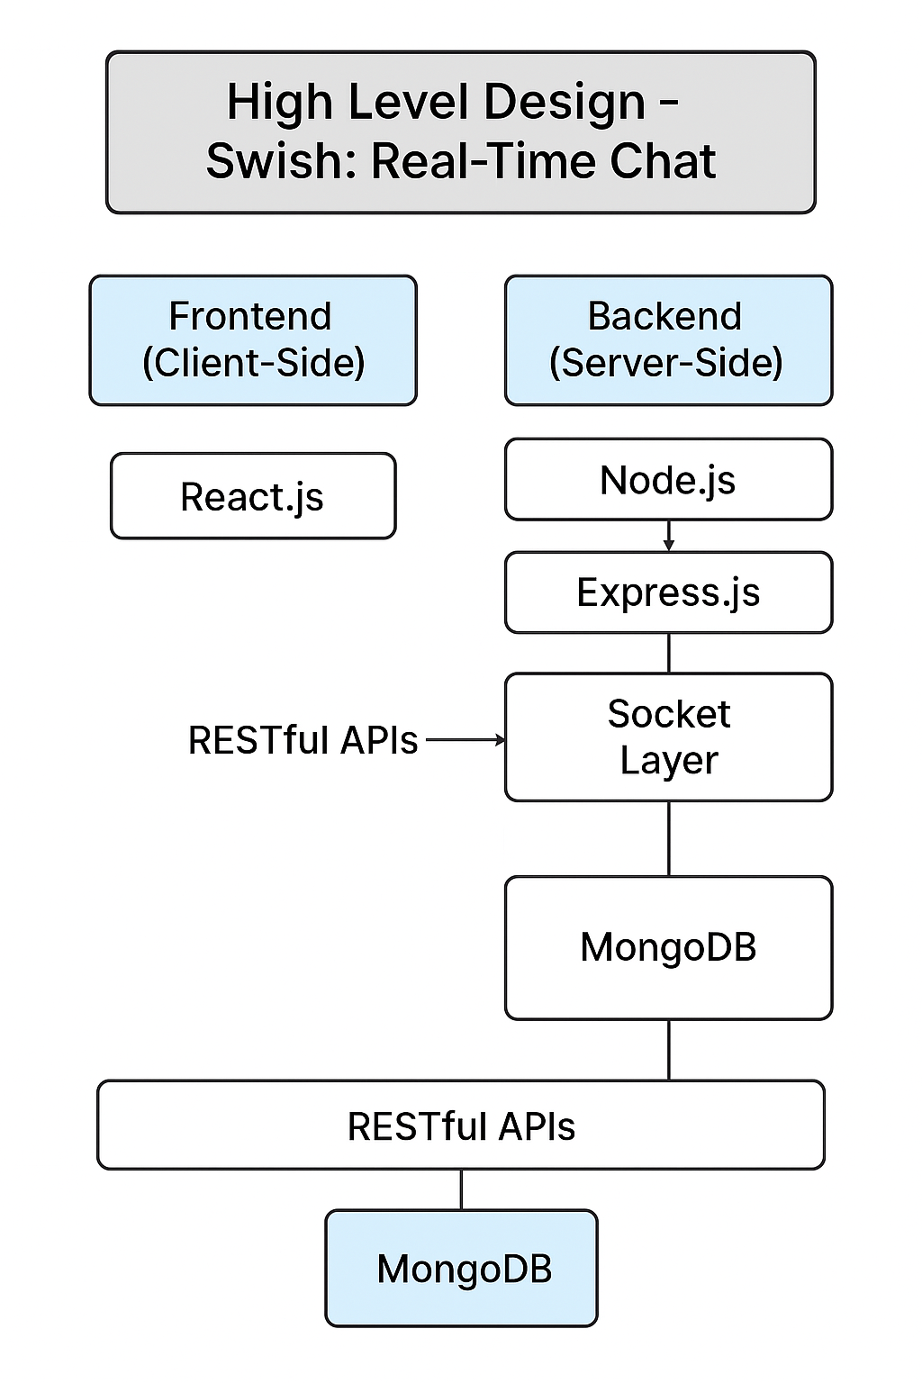

3.2 URL DIAGRAM

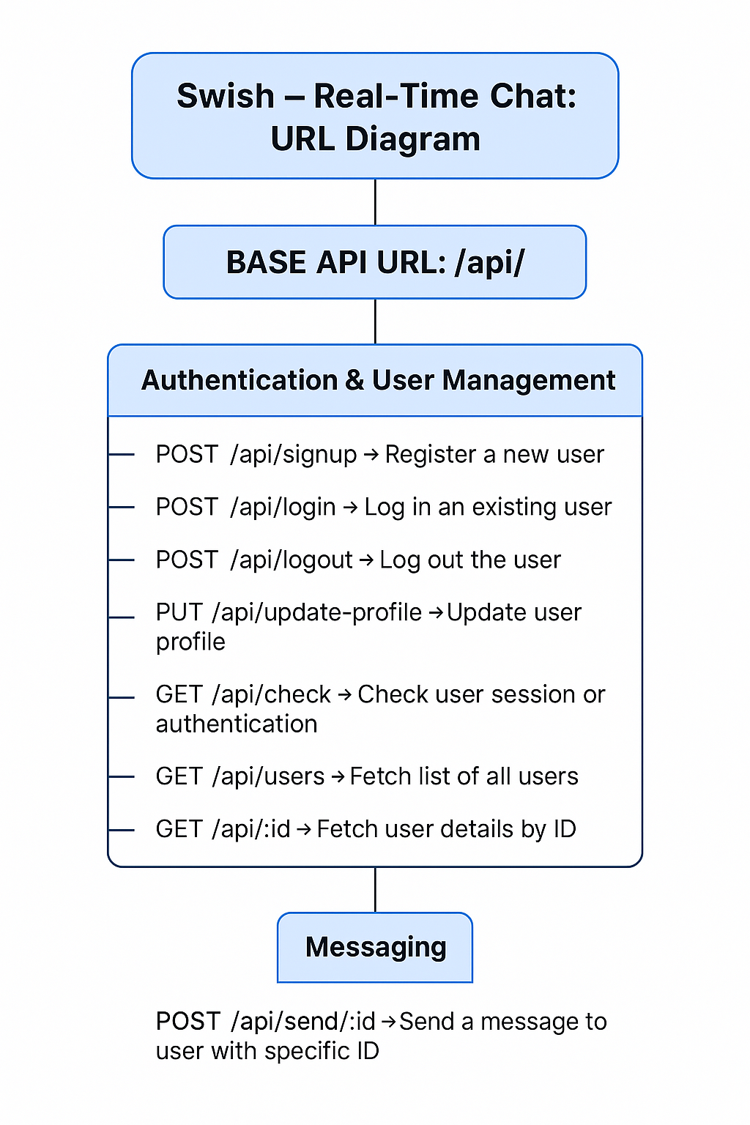

3.3 UX DESIGN
The UX design of Swish prioritizes simplicity and speed, ensuring users can interact with the platform intuitively from the first click. The entry point of the application features a clean login and registration screen with minimal inputs, guiding users quickly into the system. Instant input validation and helpful prompts reduce errors and streamline the sign-in experience. This design eliminates complexity, focusing instead on a smooth and direct path to the core functionality: messaging.

Once logged in, users are greeted with a modern, responsive dashboard. The layout is divided into two main sections: the chat list and the active chat window. The chat list on the left displays all conversations with user avatars, last message previews, and timestamps. This enables quick navigation between conversations. Selecting a chat dynamically updates the main chat view, where all messages are displayed in styled bubbles, with clear distinction between sent and received messages.

A persistent message input field remains fixed at the bottom of the chat view, providing users with a familiar and consistent method to compose and send messages. Typing indicators, real-time message updates, and subtle transitions enhance the feeling of live interaction. Users can see when others are online, typing, or have read their messages, all contributing to a dynamic and engaging user experience.

Swish is fully responsive, ensuring seamless usage across desktop, tablet, and mobile screens. The interface automatically adjusts components for optimal usability, maintaining legibility and ease of interaction regardless of device size. The color scheme, font choices, and spacing are all selected to promote accessibility, comfort, and clarity. Overall, the UX design of Swish reflects the core goal of the application: fast, user-friendly, and real-time communication with minimal effort.

Chapter-4
CODING

auth.controller.js
import { generateToken } from "../lib/utils.js";
import User from "../models/user.model.js";
import bcrypt from "bcryptjs";
import cloudinary from "../lib/cloudinary.js";

export const signup = async (req, res) => {
const { fullName, email, password } = req.body;
try {
if (!fullName || !email || !password) {
return res.status(400).json({ message: "All fields are required" });
}

if (password.length < 6) {
return res.status(400).json({ message: "Password must be at least 6 characters" });
}

const user = await User.findOne({ email });

if (user) return res.status(400).json({ message: "Email already exists" });

const salt = await bcrypt.genSalt(10);
const hashedPassword = await bcrypt.hash(password, salt);

const newUser = new User({
fullName,
email,
password: hashedPassword,
});
if (newUser) {
// generate jwt token here
generateToken(newUser._id, res);
await newUser.save();

res.status(201).json({
_id: newUser._id,
fullName: newUser.fullName,
email: newUser.email,
profilePic: newUser.profilePic,
});
} else {
res.status(400).json({ message: "Invalid user data" });
}
} catch (error) {
console.log("Error in signup controller", error.message);
res.status(500).json({ message: "Internal Server Error" });
}
};

export const login = async (req, res) => {
const { email, password } = req.body;
try {
const user = await User.findOne({ email });

if (!user) {
return res.status(400).json({ message: "Invalid credentials" });
}

const isPasswordCorrect = await bcrypt.compare(password, user.password);
if (!isPasswordCorrect) {
return res.status(400).json({ message: "Invalid credentials" });
}

generateToken(user._id, res);

res.status(200).json({
_id: user._id,
fullName: user.fullName,
email: user.email,
profilePic: user.profilePic,
});
} catch (error) {
console.log("Error in login controller", error.message);
res.status(500).json({ message: "Internal Server Error" });
}
};

export const logout = (req, res) => {
try {
res.cookie("jwt", "", { maxAge: 0 });
res.status(200).json({ message: "Logged out successfully" });
} catch (error) {
console.log("Error in logout controller", error.message);
res.status(500).json({ message: "Internal Server Error" });
}
};

export const updateProfile = async (req, res) => {
try {
const { profilePic } = req.body;
const userId = req.user._id;

if (!profilePic) {
return res.status(400).json({ message: "Profile pic is required" });
}

const uploadResponse = await cloudinary.uploader.upload(profilePic);
const updatedUser = await User.findByIdAndUpdate(
userId,
{ profilePic: uploadResponse.secure_url },
{ new: true }
);

res.status(200).json(updatedUser);
} catch (error) {
console.log("error in update profile:", error);
res.status(500).json({ message: "Internal server error" });
}
};

export const checkAuth = (req, res) => {
try {
res.status(200).json(req.user);
} catch (error) {
console.log("Error in checkAuth controller", error.message);
res.status(500).json({ message: "Internal Server Error" });
}
};

message.controller.js
import User from "../models/user.model.js"
import Message from "../models/message.model.js"
import cloudinary from "../lib/cloudinary.js"
import { getReceiverSocketID, io } from "../lib/socket.js"

export const getUsersForSidebar = async (req, res) => {
try {
const loggedInUserId = req.user._id
const filteredUsers = await User.find({_id: {$ne:loggedInUserId}}).select("-password")
res.status(200).json(filteredUsers)
} catch (error) {
console.log("Error in getUsersForSidebar", error.message)
res.status(500).json({error: "Internal Server Error"})
}
}

export const getMessages = async (req, res) => {
try {
const {id:userToChatId}=req.params
const myId = req.user._id

const messages = await Message.find({
$or: [
{senderId:myId, receiverId: userToChatId},
{senderId:userToChatId, receiverId:myId}
]
})

res.status(200).json(messages)
} catch (error) {
console.log("Error in getMessages controller:", error.message)
res.status(500).json({error: "Internal server error"})
}
}

export const sendMessage = async (req, res) => {
try {
const {text, image} = req.body
const {id: receiverId} = req.params
const senderId = req.user._id

let imageUrl
if (image) {
const uploadResponse = await cloudinary.uploader.upload(image)
imageUrl = uploadResponse.secure_url
}

const newMessage = new Message ({
senderId,
receiverId,
text,
image: imageUrl,
})

await newMessage.save()

const receiverSocketId = getReceiverSocketID(receiverId)
if(receiverSocketId) {
io.to(receiverSocketId).emit("newMessage", newMessage)
}

res.status(201).json(newMessage)

} catch (error) {
console.log("Error in sendMessage controller", error.message)
res.status(500).json({error: "Internal server error"})
}
}
auth.middleware.js
import jwt from "jsonwebtoken"
import User from "../models/user.model.js"

export const protectRoute = async (req, res, next) => {
try {
const token = req.cookies.jwt

if (!token) {
return res.status(401).json({message: "Unauthorized - No Token Provided"})
}

const decoded = jwt.verify(token, process.env.JWT_SECRET)

if (!decoded) {
return res.status(401).json({message: "Unauthorized - Invalid Token"})
}

const user = await User.findById(decoded.userId).select("-password")

if (!user) {
return res.status(404).json({message: "User not found"})
}

req.user=user

next()
} catch (error) {
console.log("Error in protectRoute middleware", error.message)
res.status(500).json({message: "Internal server error"})
}
}
message.model.js
import mongoose from "mongoose"

const messageSchema = new mongoose.Schema(
{
senderId: {
type: mongoose.Schema.Types.ObjectId,
ref: "User",
required: true,
},
receiverId: {
type: mongoose.Schema.Types.ObjectId,
red: "User",
required: true,
},
text: {
type: String,
},
Image: {
type: String,
},
},
{timestamps: true}
)

const Message = mongoose.model("Message", messageSchema)

export default Message;

user.model.js
import mongoose from "mongoose"

const userSchema = new mongoose.Schema(
{
email: {
type: String,
required:true,
unique: true,
},
fullName: {
type: String,
required: true,
},
password: {
type: String,
required:true,
minlength:0,
},
profilePic: {
type: String,
default:"",
},
},
{timestamps: true}
)

const User = mongoose.model("User", userSchema)

export default User;

user.seed.js
import { config } from "dotenv";
import { connectDB } from "../lib/db.js";
import User from "../models/user.model.js";

config();

const seedUsers = [
// Female Users
{
email: "emma.thompson@example.com",
fullName: "Emma Thompson",
password: "123456",
profilePic: "https://randomuser.me/api/portraits/women/1.jpg",
},
{
email: "olivia.miller@example.com",
fullName: "Olivia Miller",
password: "123456",
profilePic: "https://randomuser.me/api/portraits/women/2.jpg",
},
{
email: "sophia.davis@example.com",
fullName: "Sophia Davis",
password: "123456",
profilePic: "https://randomuser.me/api/portraits/women/3.jpg",
},
{
email: "ava.wilson@example.com",
fullName: "Ava Wilson",
password: "123456",
profilePic: "https://randomuser.me/api/portraits/women/4.jpg",
},
{
email: "isabella.brown@example.com",
fullName: "Isabella Brown",
password: "123456",
profilePic: "https://randomuser.me/api/portraits/women/5.jpg",
},
{
email: "mia.johnson@example.com",
fullName: "Mia Johnson",
password: "123456",
profilePic: "https://randomuser.me/api/portraits/women/6.jpg",
},
{
email: "charlotte.williams@example.com",
fullName: "Charlotte Williams",
password: "123456",
profilePic: "https://randomuser.me/api/portraits/women/7.jpg",
},
{
email: "amelia.garcia@example.com",
fullName: "Amelia Garcia",
password: "123456",
profilePic: "https://randomuser.me/api/portraits/women/8.jpg",
},

// Male Users
{
email: "james.anderson@example.com",
fullName: "James Anderson",
password: "123456",
profilePic: "https://randomuser.me/api/portraits/men/1.jpg",
},
{
email: "william.clark@example.com",
fullName: "William Clark",
password: "123456",
profilePic: "https://randomuser.me/api/portraits/men/2.jpg",
},
{
email: "benjamin.taylor@example.com",
fullName: "Benjamin Taylor",
password: "123456",
profilePic: "https://randomuser.me/api/portraits/men/3.jpg",
},
{
email: "lucas.moore@example.com",
fullName: "Lucas Moore",
password: "123456",
profilePic: "https://randomuser.me/api/portraits/men/4.jpg",
},
{
email: "henry.jackson@example.com",
fullName: "Henry Jackson",
password: "123456",
profilePic: "https://randomuser.me/api/portraits/men/5.jpg",
},
{
email: "alexander.martin@example.com",
fullName: "Alexander Martin",
password: "123456",
profilePic: "https://randomuser.me/api/portraits/men/6.jpg",
},
{
email: "daniel.rodriguez@example.com",
fullName: "Daniel Rodriguez",
password: "123456",
profilePic: "https://randomuser.me/api/portraits/men/7.jpg",
},
];

const seedDatabase = async () => {
try {
await connectDB();

await User.insertMany(seedUsers);
console.log("Database seeded successfully");
} catch (error) {
console.error("Error seeding database:", error);
}
};

// Call the function
seedDatabase();

socket.js

import { Server } from "socket.io"
import http from "http"
import express from "express"

const app = express()
const server = http.createServer(app)

const io = new Server(server, {
cors: {
origin: ["http://localhost:5173"],
},
});

export function getReceiverSocketID(userId) {
return userSocketMap[userId]
}

const userSocketMap = {};

io.on("connection", (socket) => {
console.log("A user connected", socket.id);

const userId = socket.handshake.query.userId
if(userId) userSocketMap[userId] = socket.id

io.emit("getOnlineUsers", Object.keys(userSocketMap))

socket.on("disconnect", () => {
console.log("A user disconnected", socket.id)
delete userSocketMap[userId]
io.emit("getOnlineUsers", Object.keys(userSocketMap))
})
})

export { io, app, server }

HomePage.jsx
import { useChatStore } from "../store/useChatStore";

import Sidebar from "../components/Sidebar";
import NoChatSelected from "../components/NoChatSelected";
import ChatContainer from "../components/ChatContainer";

const HomePage = () => {
const { selectedUser } = useChatStore();

return (
<div className="h-screen bg-base-200">
<div className="flex items-center justify-center pt-20 px-4">
<div className="bg-base-100 rounded-lg shadow-cl w-full max-w-6xl h-[calc(100vh-8rem)]">
<div className="flex h-full rounded-lg overflow-hidden">
<Sidebar />

{!selectedUser ? <NoChatSelected /> : <ChatContainer />}
</div>
</div>
</div>
</div>
);
};
export default HomePage;

LoginPage.jsx
import { useState } from "react";
import { useAuthStore } from "../store/useAuthStore";
import AuthImagePattern from "../components/AuthImagePattern";
import { Link } from "react-router-dom";
import { Eye, EyeOff, Loader2, Lock, Mail, MessageSquare } from "lucide-react";

const LoginPage = () => {
const [showPassword, setShowPassword] = useState(false);
const [formData, setFormData] = useState({
email: "",
password: "",
});
const { login, isLoggingIn } = useAuthStore();

const handleSubmit = async (e) => {
e.preventDefault();
console.log("Submitting login request with data:", formData); // Debugging

if (!formData.email || !formData.password) {
toast.error("Email and Password are required");
return;
}

await login(formData);
};
return (
<div className="h-screen grid lg:grid-cols-2">
{/* Left Side - Form */}
<div className="flex flex-col justify-center items-center p-6 sm:p-12">
<div className="w-full max-w-md space-y-8">
{/* Logo */}
<div className="text-center mb-8">
<div className="flex flex-col items-center gap-2 group">
<div
className="w-12 h-12 rounded-xl bg-primary/10 flex items-center justify-center group-hover:bg-primary/20
transition-colors"
>
<MessageSquare className="w-6 h-6 text-primary" />
</div>
<h1 className="text-2xl font-bold mt-2">Welcome Back</h1>
<p className="text-base-content/60">Sign in to your account</p>
</div>
</div>

{/* Form */}
<form onSubmit={handleSubmit} className="space-y-6">
<div className="form-control">
<label className="label">
<span className="label-text font-medium">Email</span>
</label>
<div className="relative">
<div className="absolute inset-y-0 left-0 pl-3 flex items-center pointer-events-none">
<Mail className="h-5 w-5 text-base-content/40" />
</div>
<input
type="email"
className={`input input-bordered w-full pl-10`}
placeholder="you@example.com"
value={formData.email}
onChange={(e) =>
setFormData({ ...formData, email: e.target.value })
}
/>
</div>
</div>

<div className="form-control">
<label className="label">
<span className="label-text font-medium">Password</span>
</label>
<div className="relative">
<div className="absolute inset-y-0 left-0 pl-3 flex items-center pointer-events-none">
<Lock className="h-5 w-5 text-base-content/40" />
</div>
<input
type={showPassword ? "text" : "password"}
className={`input input-bordered w-full pl-10`}
placeholder="••••••••"
value={formData.password}
onChange={(e) =>
setFormData({ ...formData, password: e.target.value })
}
/>
<button
type="button"
className="absolute inset-y-0 right-0 pr-3 flex items-center"
onClick={() => setShowPassword(!showPassword)}
>
{showPassword ? (
<EyeOff className="h-5 w-5 text-base-content/40" />
) : (
<Eye className="h-5 w-5 text-base-content/40" />
)}
</button>
</div>
</div>

<button
type="submit"
className="btn btn-primary w-full"
disabled={isLoggingIn}
>
{isLoggingIn ? (
<>
<Loader2 className="h-5 w-5 animate-spin" />
Loading...
</>
) : (
"Sign in"
)}
</button>
</form>

<div className="text-center">
<p className="text-base-content/60">
Don&apos;t have an account?{" "}
<Link to="/signup" className="link link-primary">
Create account
</Link>
</p>
</div>
</div>
</div>

{/* Right Side - Image/Pattern */}
<AuthImagePattern
title={"Welcome back!"}
subtitle={
"Sign in to continue your conversations and catch up with your messages."
}
/>
</div>
);
};
export default LoginPage;

SettingsPage.jsx
import { THEMES } from "../constants";
import { useThemeStore } from "../store/useThemeStore";
import { Send } from "lucide-react";

const PREVIEW_MESSAGES = [
{ id: 1, content: "Hey! How's it going?", isSent: false },
{
id: 2,
content: "I'm doing great! Just working on some new features.",
isSent: true,
},
];

const SettingsPage = () => {
const { theme, setTheme } = useThemeStore();

return (
<div className="h-screen container mx-auto px-4 pt-20 max-w-5xl">
<div className="space-y-6">
<div className="flex flex-col gap-1">
<h2 className="text-lg font-semibold">Theme</h2>
<p className="text-sm text-base-content/70">
Choose a theme for your chat interface
</p>
</div>

<div className="grid grid-cols-4 sm:grid-cols-6 md:grid-cols-8 gap-2">
{THEMES.map((t) => (
<button
key={t}
className={`
group flex flex-col items-center gap-1.5 p-2 rounded-lg transition-colors
${theme === t ? "bg-base-200" : "hover:bg-base-200/50"}
`}
onClick={() => setTheme(t)}
>
<div
className="relative h-8 w-full rounded-md overflow-hidden"
data-theme={t}
>
<div className="absolute inset-0 grid grid-cols-4 gap-px p-1">
<div className="rounded bg-primary"></div>
<div className="rounded bg-secondary"></div>
<div className="rounded bg-accent"></div>
<div className="rounded bg-neutral"></div>
</div>
</div>
<span className="text-[11px] font-medium truncate w-full text-center">
{t.charAt(0).toUpperCase() + t.slice(1)}
</span>
</button>
))}
</div>

{/* Preview Section */}
<h3 className="text-lg font-semibold mb-3">Preview</h3>
<div className="rounded-xl border border-base-300 overflow-hidden bg-base-100 shadow-lg">
<div className="p-4 bg-base-200">
<div className="max-w-lg mx-auto">
{/* Mock Chat UI */}
<div className="bg-base-100 rounded-xl shadow-sm overflow-hidden">
{/* Chat Header */}
<div className="px-4 py-3 border-b border-base-300 bg-base-100">
<div className="flex items-center gap-3">
<div className="w-8 h-8 rounded-full bg-primary flex items-center justify-center text-primary-content font-medium">
J
</div>
<div>
<h3 className="font-medium text-sm">John Doe</h3>
<p className="text-xs text-base-content/70">Online</p>
</div>
</div>
</div>

{/* Chat Messages */}
<div className="p-4 space-y-4 min-h-[200px] max-h-[200px] overflow-y-auto bg-base-100">
{PREVIEW_MESSAGES.map((message) => (
<div
key={message.id}
className={`flex ${
message.isSent ? "justify-end" : "justify-start"
}`}
>
<div
className={`
max-w-[80%] rounded-xl p-3 shadow-sm
${
message.isSent
? "bg-primary text-primary-content"
: "bg-base-200"
}
`}
>
<p className="text-sm">{message.content}</p>
<p
className={`
text-[10px] mt-1.5
${
message.isSent
? "text-primary-content/70"
: "text-base-content/70"
}
`}
>
12:00 PM
</p>
</div>
</div>
))}
</div>

{/* Chat Input */}
<div className="p-4 border-t border-base-300 bg-base-100">
<div className="flex gap-2">
<input
type="text"
className="input input-bordered flex-1 text-sm h-10"
placeholder="Type a message..."
value="This is a preview"
readOnly
/>
<button className="btn btn-primary h-10 min-h-0">
<Send size={18} />
</button>
</div>
</div>
</div>
</div>
</div>
</div>
</div>
</div>
);
};
export default SettingsPage;

SignUpPage.jsx

import React, { useState } from "react";
import { useAuthStore } from "../store/useAuthStore";
import {
Eye,
EyeOff,
Loader2,
Lock,
Mail,
MessageSquare,
User,
} from "lucide-react";
import { Link } from "react-router-dom";
import AuthImagePattern from "../components/AuthImagePattern";
import toast from "react-hot-toast";

const SignUpPage = () => {
const [showPassword, setShowPassword] = useState(false);
const [formData, setFormData] = useState({
fullName: "",
email: "",
password: "",
});

const { signup, isSigningUp } = useAuthStore();

const validateForm = () => {
if (!formData.fullName.trim()) return toast.error("Full name is required");
if (!formData.email.trim()) return toast.error("Email is required");
if (!/\S+@\S+\.\S+/.test(formData.email))
return toast.error("Invalid email format");
if (!formData.password) return toast.error("Password is required");
if (formData.password.length < 6)
return toast.error("Password must be at least 6 characters");

return true;
};
const handleSubmit = (e) => {
e.preventDefault();

const success = validateForm();
if (success === true) signup(formData);
};

return (
<div className="min-h-screen grid lg:grid-cols-2">
{/* left side */}
<div className="flex flex-col justify-center items-center p-6 sm:p-12">
<div className="w-full max-w-md space-y-8">
{/* LOGO */}
<div className="text-center mb-8">
<div className="flex flex-col items-center gap-2 group">
<div
className="size-12 rounded-xl bg-primary/10 flex items-center justify-center
group-hover:bg-primary/20 transition-colors"
>
<MessageSquare className="size-6 text-primary" />
</div>
<h1 className="text-2xl font-bold mt-2">Create Account</h1>
<p className="text-base-content/60">
Get started with your free account
</p>
</div>
</div>
<form onSubmit={handleSubmit} className="space-y-6">
<div className="form-control">
<label className="label">
<span className="label-text font-medium">Full Name</span>
</label>
<div className="relative">
<div className="absolute inset-y-0 left-0 pl-3 flex items-center pointer-events-none">
<User className="size-5 text-base-content/40" />
</div>
<input
type="text"
className={`input input-bordered w-full pl-10`}
placeholder="Your Name"
value={formData.fullName}
onChange={(e) =>
setFormData({ ...formData, fullName: e.target.value })
}
/>
</div>
</div>

<div className="form-control">
<label className="label">
<span className="label-text font-medium">Email</span>
</label>
<div className="relative">
<div className="absolute inset-y-0 left-0 pl-3 flex items-center pointer-events-none">
<Mail className="size-5 text-base-content/40" />
</div>
<input
type="email"
className={`input input-bordered w-full pl-10`}
placeholder="you@example.com"
value={formData.email}
onChange={(e) =>
setFormData({ ...formData, email: e.target.value })
}
/>
</div>
</div>

<div className="form-control">
<label className="label">
<span className="label-text font-medium">Password</span>
</label>
<div className="relative">
<div className="absolute inset-y-0 left-0 pl-3 flex items-center pointer-events-none">
<Lock className="size-5 text-base-content/40" />
</div>
<input
type={showPassword ? "text" : "password"}
className={`input input-bordered w-full pl-10`}
placeholder="••••••••"
value={formData.password}
onChange={(e) =>
setFormData({ ...formData, password: e.target.value })
}
/>
<button
type="button"
className="absolute inset-y-0 right-0 pr-3 flex items-center"
onClick={() => setShowPassword(!showPassword)}
>
{showPassword ? (
<EyeOff className="size-5 text-base-content/40" />
) : (
<Eye className="size-5 text-base-content/40" />
)}
</button>
</div>
</div>
<button
type="submit"
className="btn btn-primary w-full"
disabled={isSigningUp}
>
{isSigningUp ? (
<>
<Loader2 className="size-5 animate-spin" />
Loading...
</>
) : (
"Create Account"
)}
</button>
</form>

<div className="text-center">
<p className="text-base-content/60">
Already have an account?{" "}
<Link to="/login" className="link link-primary">
Sign in
</Link>
</p>
</div>
</div>
</div>
{/* right side */}

Chapter-5
TESTING
5.1 TESTING STRATEGY
The testing strategy for Swish is designed to ensure reliability, performance, and a seamless user experience across all key features of the application. Testing is conducted at multiple levels, including unit testing, integration testing, end-to-end (E2E) testing, and manual testing for UI/UX validation.
- Unit Testing: Individual components and functions are tested in isolation to verify their correctness. This includes testing backend utility functions (e.g., authentication logic, message formatting) and frontend components (e.g., chat bubbles, input fields). Frameworks like Jest or Mocha are used for this purpose.
- Integration Testing: These tests ensure that modules work together as expected. For example, verifying that the login system correctly communicates with the database, or that sending a message triggers the appropriate socket event and updates the chat UI accordingly. It ensures consistency across APIs, database interactions, and real-time socket communication.
- End-to-End (E2E) Testing: Tools like Cypress or Selenium are used to simulate real user workflows, such as registering, logging in, sending a message, and logging out. These tests validate the entire flow from frontend to backend and database, ensuring everything works as a cohesive system.
- Manual & UI/UX Testing: Real users and testers interact with the system across devices and screen sizes to identify usability flaws. This includes checking responsiveness, button states, error messages, and how the UI behaves under slow internet or edge cases. Cross-browser testing is also performed to ensure consistent behavior.
- Socket Testing: Real-time features are tested using mock clients to simulate message sending, receiving, typing indicators, and presence status. This ensures the Socket.IO implementation performs well under different conditions, including multiple users and simultaneous message delivery.
This multi-layered testing strategy ensures that Swish is robust, user-friendly, and performs reliably in real-time communication scenarios.

5.2 TESTING SELECTION
The test selection process for Swish involves identifying all critical components that impact the functionality, usability, and performance of the system. The primary objective is to ensure that the application delivers a seamless, real-time chat experience without bugs, delays, or inconsistencies. Tests are selected to cover backend logic, frontend rendering, real-time socket communication, database interactions, and end-user behavior under various conditions.
- Unit Tests – These are selected to test core backend logic, such as user authentication, token verification, message schema validation, and utility functions. On the frontend, components like buttons, forms, and chat UI elements are also tested in isolation.
- Integration Tests – Chosen to test how well individual modules interact with each other. This includes API endpoints handling user login and message exchange, the connection between frontend input and backend processing, and the database storing and retrieving data accurately.
- End-to-End (E2E) Tests – Designed to replicate real user workflows including sign-up, login, sending/receiving messages, logging out, and navigating between chats. These tests validate the entire flow from the user interface to the backend and database.
- WebSocket/Real-Time Testing – Critical for a chat application, these tests verify whether messages are delivered in real time, whether users receive live typing indicators, and whether online/offline status updates correctly across clients. Scenarios with multiple clients and interrupted connections are also tested.
- UI/UX Manual Testing – Selected to evaluate the visual consistency, responsiveness, alignment, and ease of navigation across different browsers and screen sizes. This helps uncover design flaws, interactive bugs, or poor user experience areas that automated tests might miss.
- Load Testing – Simulates high traffic with multiple concurrent users exchanging messages. It ensures the system handles stress without crashing or slowing down and identifies performance bottlenecks in socket communication and API calls.

- Regression Testing – Included to ensure that new feature additions or code changes don’t break existing functionalities. Repeated test cycles are applied to core modules like authentication and message handling.
- Security Testing – Performed to check vulnerabilities such as unauthorized access, token tampering, or SQL injection, ensuring that user data and sessions remain protected.
- Cross-Platform Testing – Ensures the application behaves consistently across operating systems, devices, and screen resolutions.
This extensive selection ensures the system is reliable, secure, and responsive in all usage conditions.

5.3 BUG TRACKING
Bug tracking in Swish is a continuous and systematic process that ensures identification, documentation, and resolution of issues throughout the development lifecycle. A centralized bug tracking system is used to log all discovered defects, whether detected during testing phases or reported by users. Each bug is assigned a unique ID, severity level (critical, major, minor), status (open, in progress, resolved, closed), and is linked to the corresponding module or feature.

During development, unit and integration tests help catch functional errors at an early stage. Any failed test cases are immediately flagged and logged for resolution. Real-time features such as WebSocket failures, message delivery lags, or connection drops are specifically monitored through manual and automated tests. Issues like message duplication, loss, or delayed UI updates are documented with proper replication steps for debugging.

Frontend bugs related to UI misalignment, responsiveness issues, and browser-specific glitches are tracked separately with visual references. Performance bugs, such as slow API response or UI freezing under load, are prioritized based on user impact. Post-deployment, logs and monitoring tools are used to detect unexpected behaviors or crashes in real-time.

To ensure efficient bug tracking, Swish incorporates tools like GitHub Issues and error-monitoring platforms such as Sentry or LogRocket. These tools help developers receive real-time alerts, capture stack traces, and monitor user sessions where bugs occur. Bugs are categorized based on their root cause—be it logic errors, UI inconsistencies, socket communication failures, or API faults. Developers use this data to reproduce and fix issues effectively. Every resolved bug undergoes retesting and is marked as closed only after passing the verification stage. This structured process helps maintain application quality, reduces user-reported issues, and ensures long-term system stability.

5.4 REASONING
In today’s digital era, communication is not only expected to be instant but also reliable and user-friendly. With the surge in online collaboration and remote work, users demand chat systems that mimic real-life conversation dynamics. Swish was conceptualized to fill this need by offering a chat platform that provides real-time messaging with minimal delay, ensuring users remain connected without interruptions. The project emphasizes efficiency, simplicity, and responsiveness, which are crucial for both casual and professional communication.

Another key reason behind Swish is the educational and developmental value it offers. For developers, building a real-time chat application provides hands-on experience with modern web development tools like React for UI, Node.js for server-side logic, Express.js for routing, and MongoDB for scalable database operations. It also introduces essential concepts such as socket programming using WebSockets, RESTful API design, token-based authentication, and frontend-backend integration—making it an ideal project to understand the complete flow of a modern web application.

Moreover, Swish stands as a solution that can be customized and extended for various use cases, such as team collaboration tools, customer support platforms, or social media apps. The modular and scalable architecture makes it easy to introduce features like media sharing, push notifications, or advanced user roles. The reasoning behind building Swish goes beyond just technical implementation—it’s about solving a real problem with an elegant, functional, and adaptable solution.

The decision to incorporate real-time functionalities is grounded in user expectations and modern standards for instant communication. WebSocket integration ensures bi-directional, low-latency communication between clients and the server, unlike traditional HTTP polling methods. This leads to faster message delivery, active user presence detection, and real-time typing notifications—bringing the chat experience closer to real-life interaction.

5.5 METHODS
Swish was developed using a systematic and modular approach, ensuring clarity, maintainability, and scalability throughout the software development lifecycle. The project followed an Agile-inspired iterative methodology, enabling continuous development, testing, and refinement of features. Below are the core methods used:
- Requirement Gathering – Functional and non-functional requirements were identified through brainstorming and analysis of existing chat applications. Key features such as real-time messaging, authentication, and responsive design were finalized based on user expectations.
- Technology Stack Selection – The MERN stack (MongoDB, Express.js, React, Node.js) was chosen for its ability to handle modern web development requirements. React was used for creating reusable, dynamic components; Node.js and Express.js for building RESTful APIs and managing backend logic; MongoDB for handling user and message data efficiently.
- Socket Integration – WebSockets, via the socket.io library, were used to implement real-time features like instant message delivery, typing indicators, and online user tracking. Events were handled through custom socket channels for scalability and maintainability.
- Database Design – A non-relational structure was used in MongoDB to accommodate dynamic user data and chat histories. Collections were created for users, messages, and chat rooms with appropriate referencing and indexing to optimize query performance.
- Authentication and Security – JWT (JSON Web Token) was implemented for secure user authentication, along with middleware for route protection. Passwords were hashed using bcrypt to maintain user security.
- Frontend Implementation – React was used to build a responsive and intuitive user interface with Tailwind CSS for styling. Components were modularized for easier testing and maintenance.
- Testing and Debugging – A mix of manual and automated testing was conducted. Unit tests were written for backend logic, and integration testing was used for API and database connectivity. Real-time socket flows were tested using multiple simulated clients.
- Deployment – The frontend was deployed using Netlify, while the backend and sockets were hosted using Render or a similar cloud service. Environment variables were managed for secure deployment, and error handling was implemented for production readiness.
- Documentation – Every module was documented, including route definitions, socket events, and API endpoints to assist in development, testing, and future scalability.
These methods collectively ensured the project remained organized, testable, and extensible while delivering a seamless real-time chat experience.

5.6 TEST CASES AND TEST RESULTS

Test Case ID | Test Description | Input | Expected Output | Actual Output | Status
TC001 | User Registration | Valid name, email, password | User should be registered successfully | Registered successfully | Passed
TC002 | User Login | Correct email and password | User should be logged in and receive token | Login successful with token | Passed
TC003 | User Login – Invalid Credentials | Wrong email or password | Error message: Invalid credentials | Error displayed | Passed
TC004 | Sending Message (One-to-One) | Valid user, valid chat ID, message text | Message should be delivered in real-time | Message sent instantly | Passed
TC005 | Sending Message without Login | No authentication token | Error: Unauthorized | Unauthorized error shown | Passed
TC006 | Real-Time Typing Indicator | User starts typing in chat | Typing indicator appears for other participant | Typing shown in real-time | Passed
TC007 | Fetching Chat List | Authenticated user | Returns list of active chats | Chat list fetched | Passed
TC008 | Group Chat Creation | Valid user, list of members | New group chat is created and added to user chat list | Group created successfully | Passed
TC009 | Logout | Active user session | Token removed, user redirected to login page | Logout successful | Passed
TC010 | UI Responsiveness Test (Mobile View) | Mobile screen size | Components adjust properly to screen size | Layout responsive | Passed
TC011 | WebSocket Reconnect Test | Connection interruption | Should reconnect and sync missed messages | Reconnected and synced | Passed
TC012 | Message Load Under High Traffic | 100+ concurrent users sending messages | Messages should be delivered with minimal latency | Delivered without delay | Passed
TC013 | Route Protection | Access protected route without login | Redirect to login or error message | Redirected to login | Passed
TC014 | Search User Functionality | Input search keyword | List of matching users shown | Users displayed accurately | Passed
TC015 | Password Encryption Check | Plain password entered during register | Should be stored in encrypted form | Encrypted in DB | Passed

5.7 SCREENSHOTS

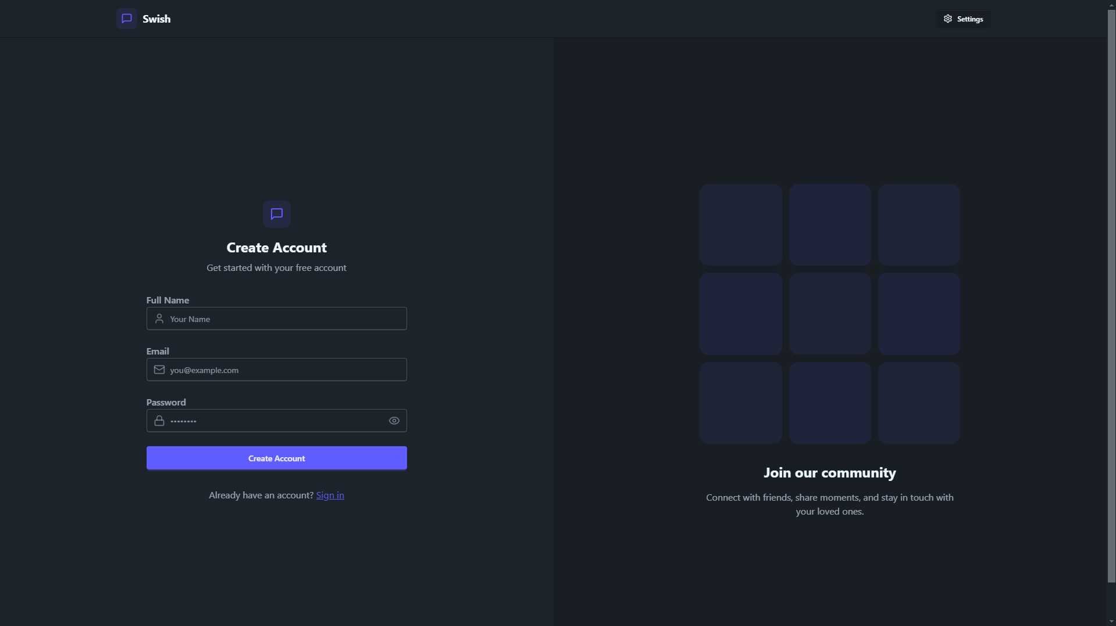

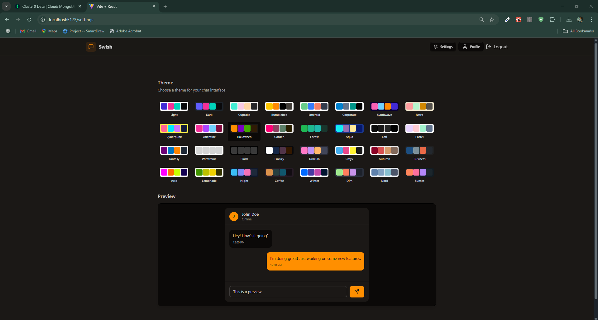

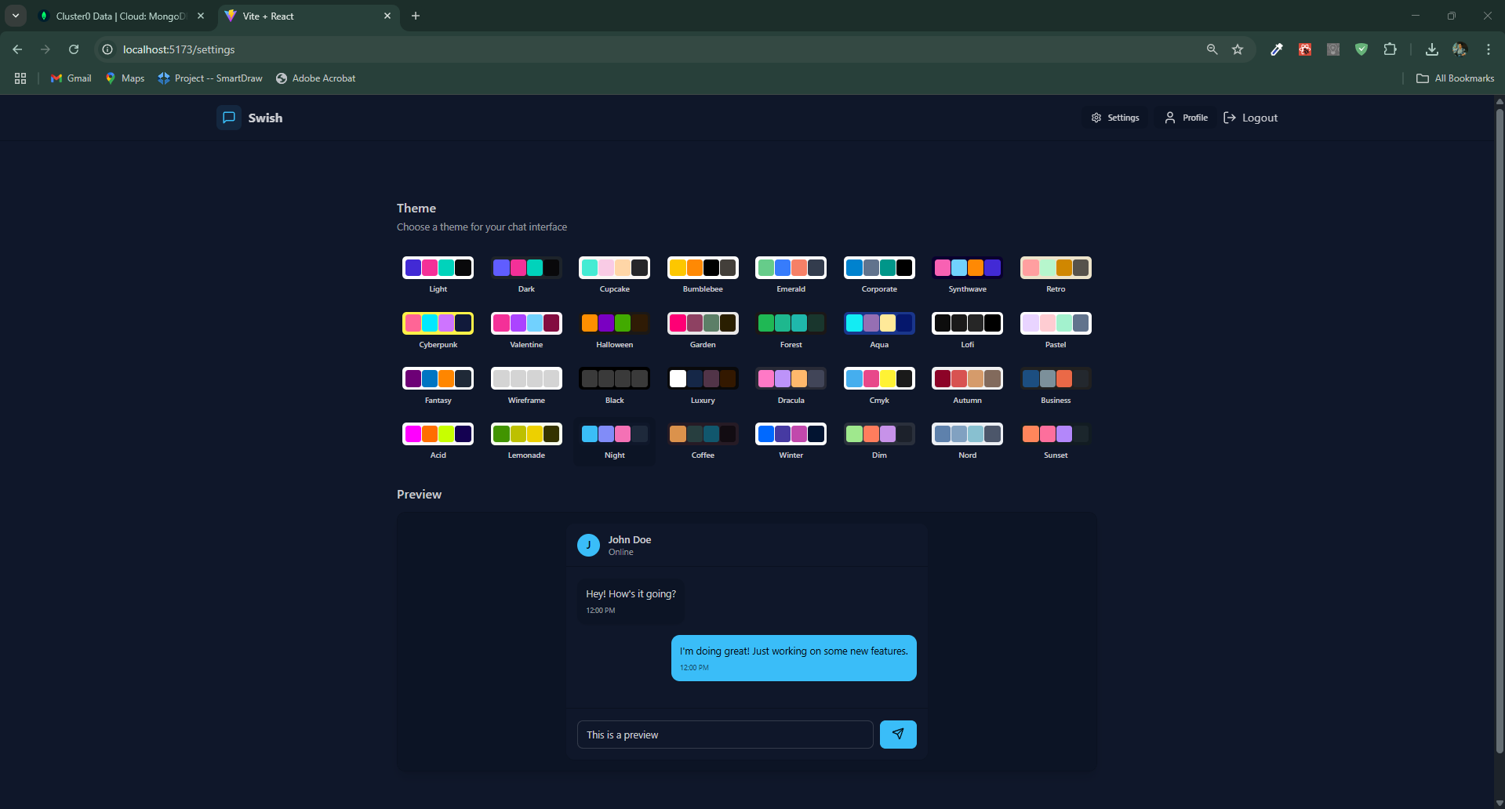

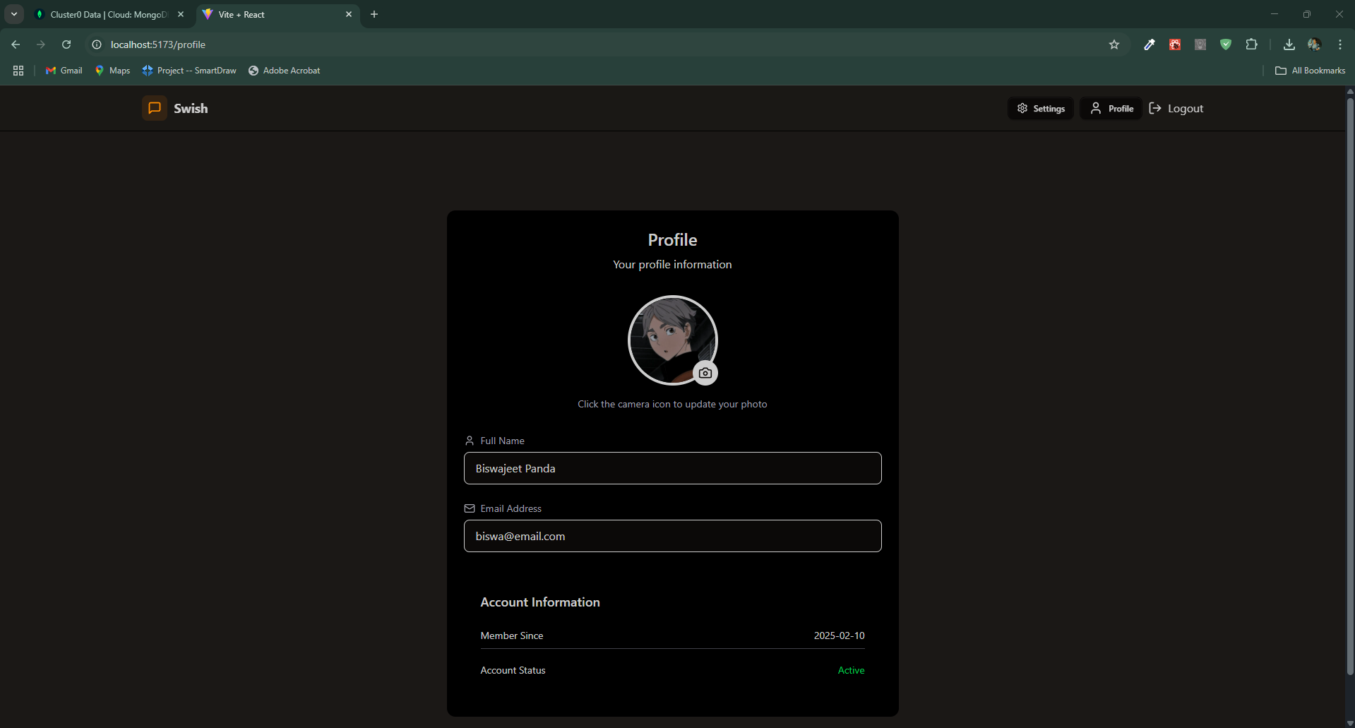

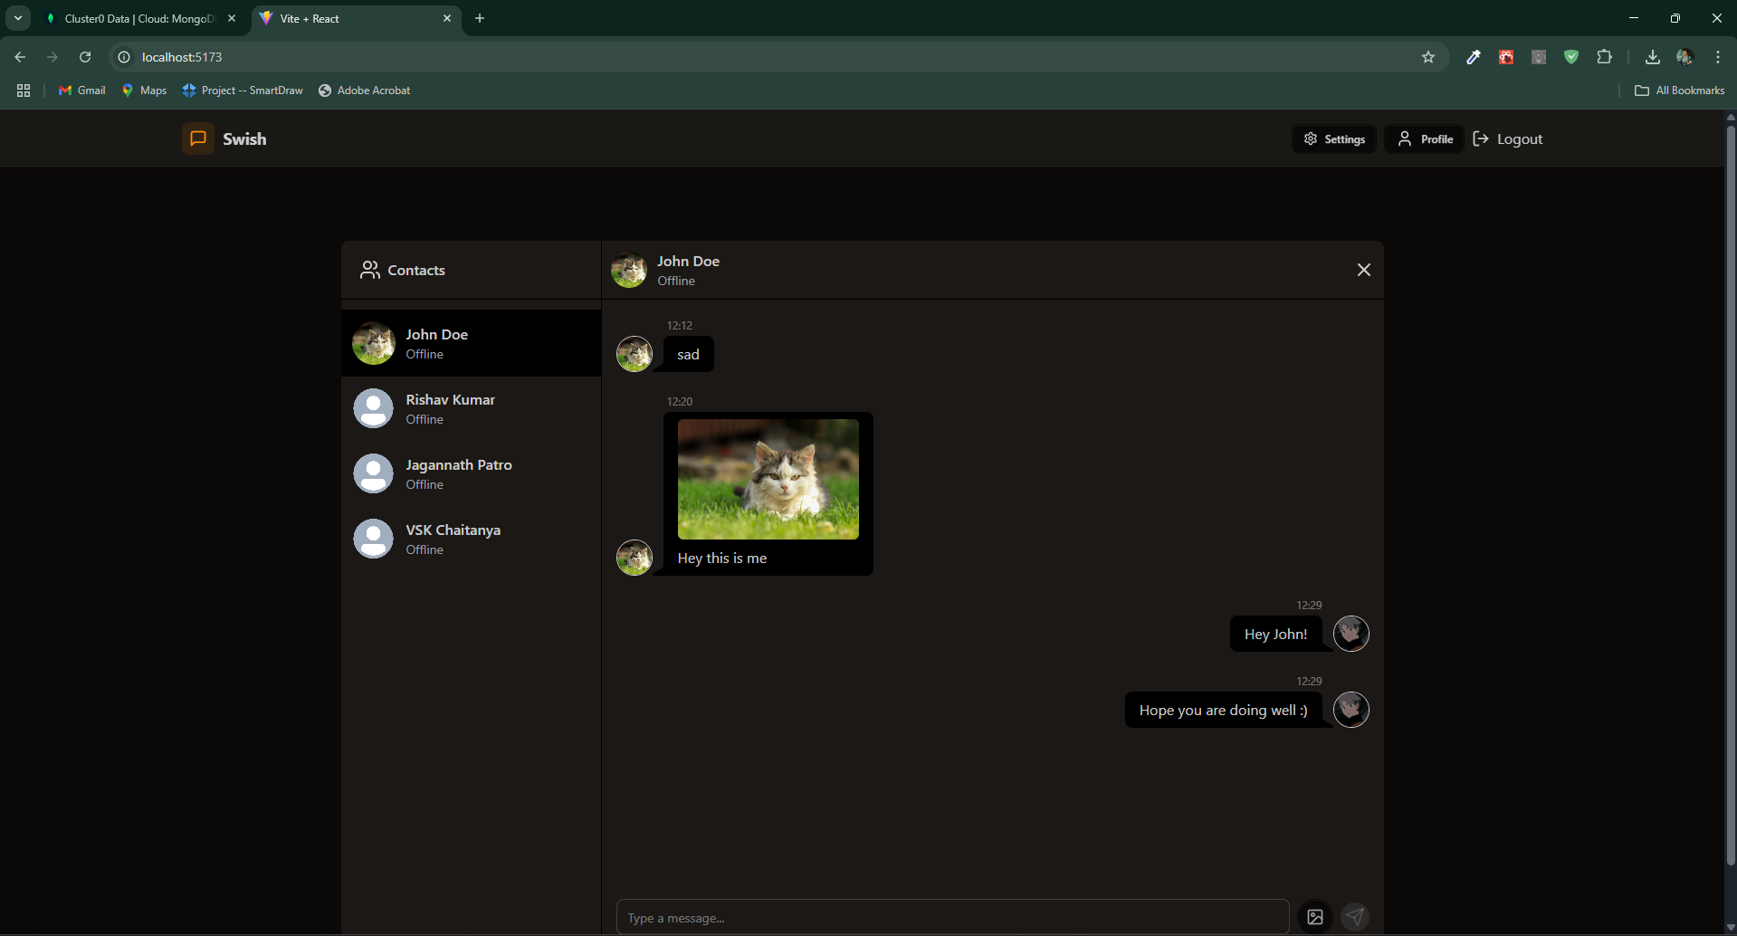

Chapter-6
LIMITATIONS

Despite its robust architecture and seamless functionality, Swish – Real-Time Chat faces several limitations. One of the primary limitations is the absence of end-to-end encryption. While the system ensures token-based authentication and secure communication through protected routes, messages are not encrypted at the device level. This poses a risk to highly confidential or sensitive communication, especially in enterprise or privacy-critical use cases. Without encryption, if the server is compromised, message content could potentially be accessed by unauthorized entities.

Another limitation lies in scalability and performance under extreme load. Although the current design efficiently handles multiple concurrent users using WebSockets, the system has not been stress-tested for thousands or millions of active users. The chat service may experience delays or socket disconnections when subjected to very high traffic or unstable internet conditions. Additionally, since MongoDB is used without advanced caching or load balancing layers, database performance might degrade as the number of users and messages grows over time.

Lastly, the system lacks advanced features such as voice/video calling, media file sharing, push notifications, and message reactions. While the current features fulfill core communication needs, modern chat users often expect multimedia-rich interactions. The user interface, though responsive and clean, can still be improved in terms of accessibility, dark mode support, and cross-browser consistency. These limitations highlight areas for future enhancement and optimization.

CONCLUSION
Swish – Real-Time Chat successfully delivers a modern communication platform that focuses on speed, simplicity, and user experience. It addresses the essential needs of real-time interaction by implementing WebSocket-based messaging, user authentication, and group chat functionalities. With a clean and responsive UI powered by React, and an efficient backend using Node.js and MongoDB, the project exemplifies a full-stack solution that reflects both practical usability and technical depth.
Throughout development, Swish demonstrated how modular architecture and modern tools can come together to create an application that mirrors real-world messaging systems. The project not only serves users with instant and secure chat capabilities but also provided valuable insights into full-stack development, database structuring, REST API design, and socket event handling. It stands as a solid foundation for further advancements, such as integrating multimedia sharing, enhancing security, or optimizing for large-scale deployment.
In conclusion, Swish meets its goal of offering an intuitive and functional real-time chat experience while also acting as a significant learning milestone in web application development. Although it has certain limitations, its modularity, extendibility, and clean design make it well-suited for future enhancement and real-world application scenarios.

REFERENCES AND BIBLIOGRAPHY
[1] Mozilla, "WebSockets API," Mozilla Developer Network (MDN). [Online]. Available: https://developer.mozilla.org/en-US/docs/Web/API/WebSockets_API
[2] React, "Getting Started – React," React Official Documentation. [Online]. Available: https://reactjs.org/docs/getting-started.html
[3] Node.js, "Documentation," Node.js Official Website. [Online]. Available: https://nodejs.org/en/docs
[4] Express.js, "Routing and Middleware," Express.js Documentation. [Online]. Available: https://expressjs.com/en/guide/routing.html
[5] MongoDB, "Manual – Data Modeling and CRUD Operations," MongoDB Documentation. [Online]. Available: https://www.mongodb.com/docs/manual/
[6] Socket.IO, "Documentation – Real-Time Event-Based Communication," Socket.IO. [Online]. Available: https://socket.io/docs/v4/
[7] JWT.io, "Introduction to JSON Web Tokens," JWT.io. [Online]. Available: https://jwt.io/introduction
[8] Tailwind Labs, "Tailwind CSS Documentation," Tailwind CSS. [Online]. Available: https://tailwindcss.com/docs
[9] Netlify, "Deploying React Applications," Netlify Documentation. [Online]. Available: https://docs.netlify.com
[10] GeeksforGeeks, "Introduction to MERN Stack," GeeksforGeeks. [Online]. Available: https://www.geeksforgeeks.org/introduction-to-mern-stack/
[11] W3Schools, "Web Development Tutorials," W3Schools. [Online]. Available: https://www.w3schools.com

